***NAME : Himanshu Dixit***

***ENROLL NO. : B64178***

***BATCH : B10***

***SOFTWARE DEVELOPMENT FUNDAMENTAL LAB-I(15B17CI171) Assignment Sheet (WEEK-9 PHASE-2)***

***Lab A***

***Q1)*** *Write a C program using pointer to declare var with value 20 and print the value of the ptr, var and *ptr.*

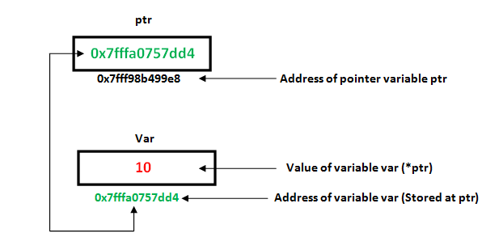

**Solution:**

#include <stdio.h>

void main()

{

int var = 20, *ptr;

ptr = &var;

printf("ptr = %d \n",ptr);

printf("var = %d \n",var);

printf("*ptr = %d \n", *ptr);

}

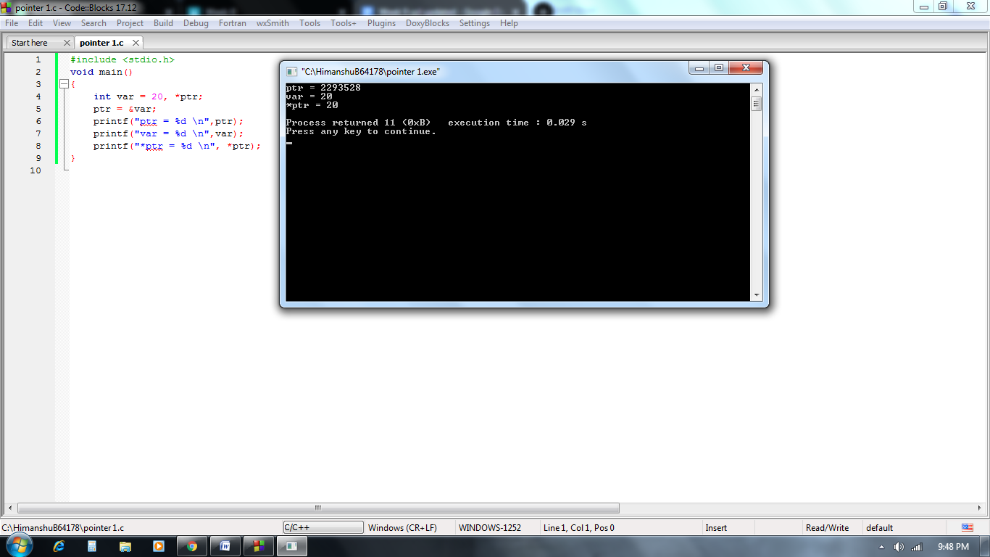

***Q2)*** *Write a C program to accept 5 numbers, store them in array and find out the smallest number using pointer.*

**Solution:**

#include<stdio.h>

int main()

{

int a[5],*s, small;

printf("Enter 5-Elements :\n");

for(int i=0;i<5;i++,s++)

scanf("%d",&a[i]);

s=a;

small=*s;

for(int i=0;i<5;i++)

{

if(*s<small)

small=*s;

s++;

}

printf("Smallest Element : %d", small);

return 0;

}

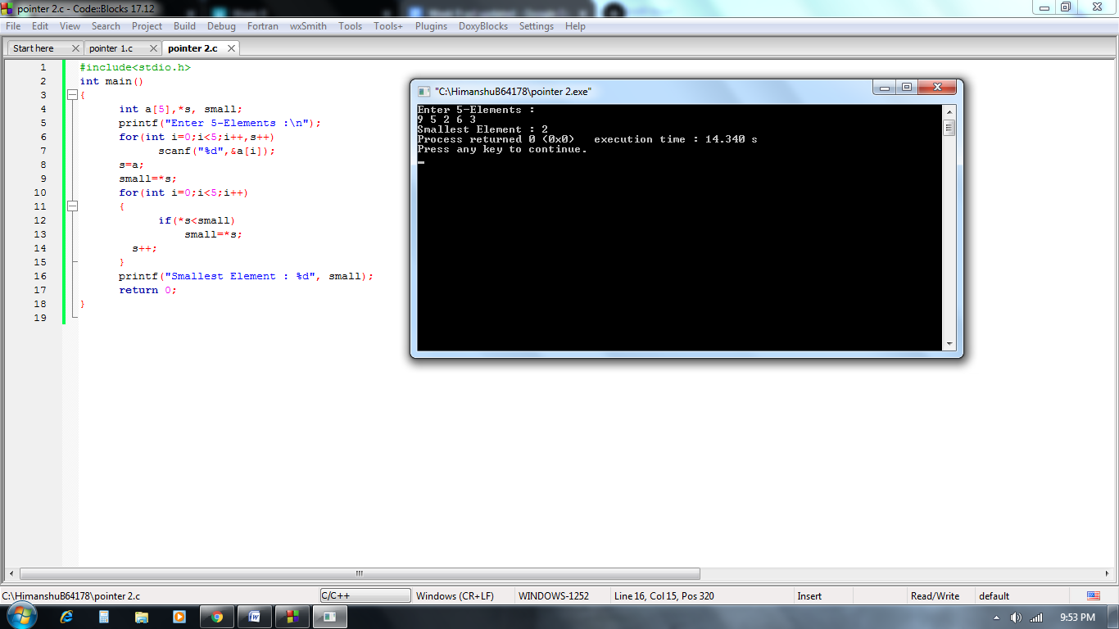

***Q3)*** *Write a 'C' Program to accept m X n matrix and find the largest and smallest number from the matrix using dynamic memory allocation.*

**Solution:**

#include<stdio.h>

#include<stdlib.h>

int main()

{

int **a, row,col,i,j,l,s;

printf("Rows : ");

scanf("%d",&row);

printf("Columns : ");

scanf("%d",&col);

a=(int **)malloc(row*sizeof(int*));

for(i=0;i<row;i++)

{

a[i]=(int *)malloc(col*sizeof(int));

}

printf("\nEnter Elements for Matrix ");

for(i=0;i<row;i++)

{

for(j=0;j<col;j++)

{

scanf("%d",&a[i][j]);

}

}

l=a[0][0];

s=a[0][0];

for(i=0;i<row;i++)

{

for(j=0;j<col;j++)

{

if(l<a[i][j])

l=a[i][j];

if(s>a[i][j])

s=a[i][j];

}

}

printf("\n%d*%d Matrix : \n\n",row,col);

for(i=0;i<row;i++)

{

for(j=0;j<col;j++)

{

printf("%d ",a[i][j]);

}

printf("\n");

}

printf("\nSmallest Element is: %d", s);

printf("\n\nLargest Element is: %d" , l);

return 0;

}

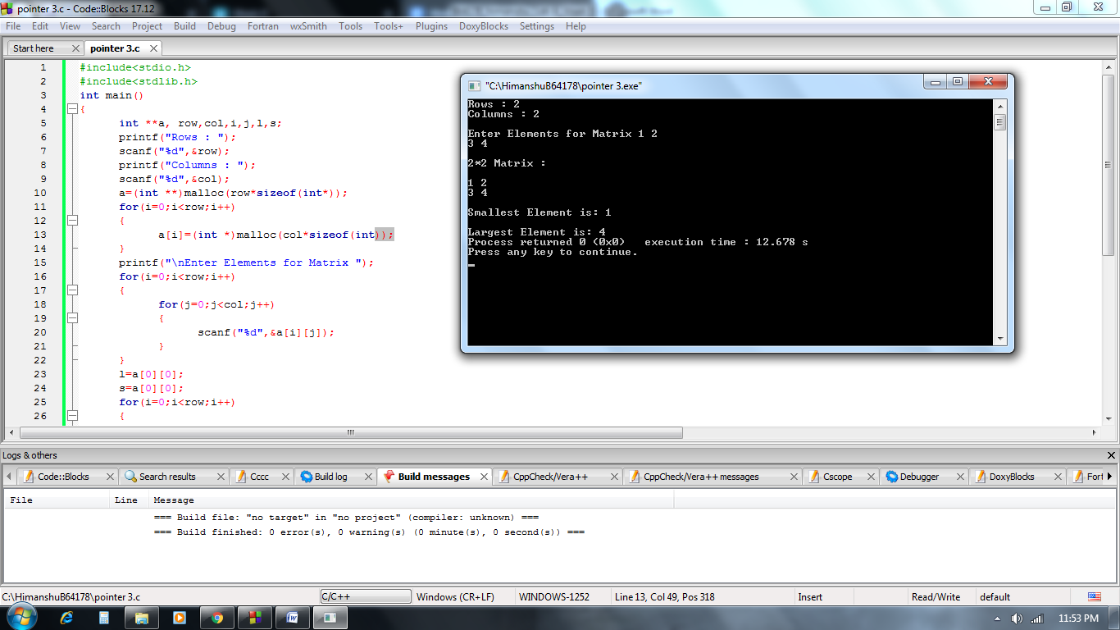

***Q4)*** *Write a 'C' program to reverse an array's elements using dynamic memory allocation.*

**Solution:**

#include<stdio.h>

#include<stdlib.h>

int main()

{

int *p,n,i;

printf("How many numbers you want to enter: ");

scanf("%d",&n);

p=(int*)malloc(n * sizeof(int));

for(i=0;i<n;i++)

{

scanf("%d",p+i);

}

printf("\nArray in Reverse Order: ");

for(i=n-1;i>=0;i--)

{

printf(" %d",*(p+i));

}

return 0;

}

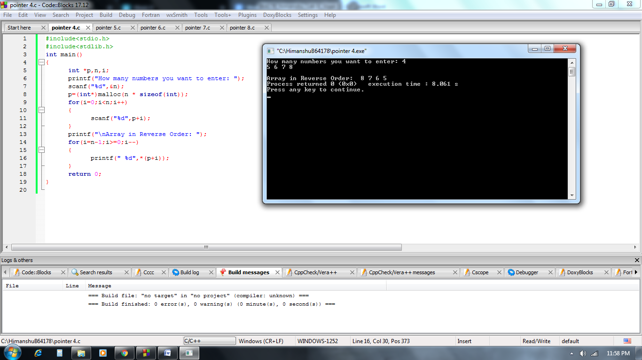

***Q5)*** *Write a C* [*Program to count vowels and consonants in a string using pointer.*](https://www.includehelp.com/c-programs/c-pointer-program-to-count-vowels-and-consonants-in-a-string-using-pointer.aspx)

**Solution:**

#include <stdio.h>

int main()

{

char str[100];

char *ptr;

int cntV=0,cntC=0;

printf("Enter a string: ");

gets(str);

ptr=str;

while(*ptr!='\0')

{

if(*ptr=='A' ||*ptr=='E' ||*ptr=='I' ||*ptr=='O' ||*ptr=='U' ||*ptr=='a' ||*ptr=='e' ||*ptr=='i' ||*ptr=='o' ||*ptr=='u')

cntV++;

else

cntC++;

ptr++;

}

printf("Total number of VOWELS: %d, CONSONANT: %d\n",cntV,cntC);

return 0;

}

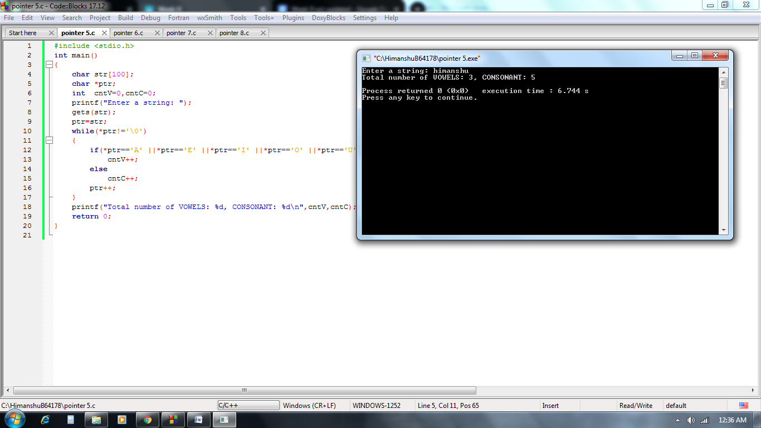

***Q6)****Write a C program given two integer numbers, and to swap their values using pointers.*

**Solution:**

#include <stdio.h>

void swap(int *a,int *b)

{

int t;

t = *a;

*a = *b;

*b = t;

}

int main()

{

int num1,num2;

printf("Enter value of num1: ");

scanf("%d",&num1);

printf("Enter value of num2: ");

scanf("%d",&num2);

printf("Before Swapping: num1=%d, num2=%d\n",num1,num2);

swap(&num1,&num2);

printf("After Swapping: num1=%d, num2=%d\n",num1,num2);

return 0;

}

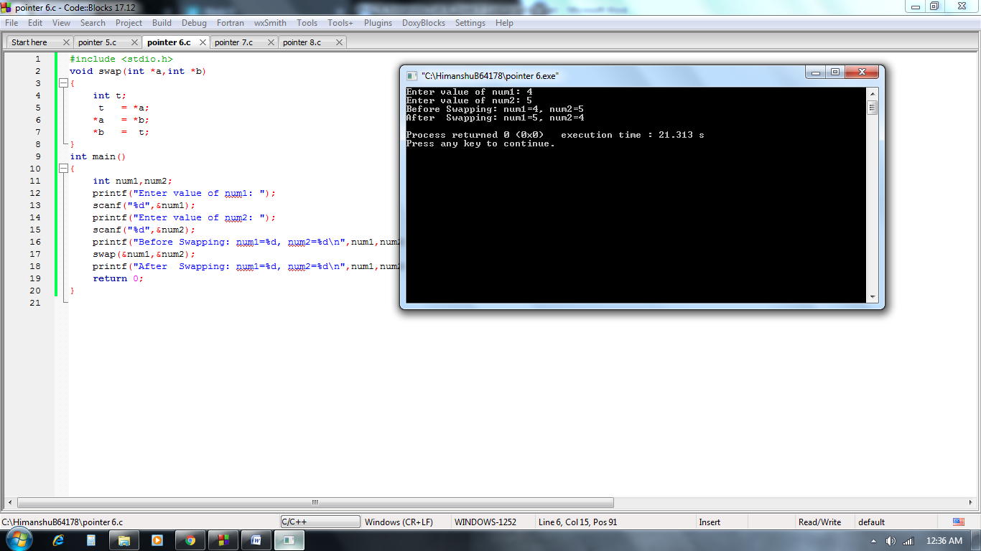

***Q7)****Write a C program to change the value of constant integer using pointers.*

**Solution:**

#include <stdio.h>

int main()

{

const int a=10;

int *p;

p=&a;

printf("Before changing a : %d",a);

*p=20;

printf("\nAfter changing a: %d",a);

return 0;

}

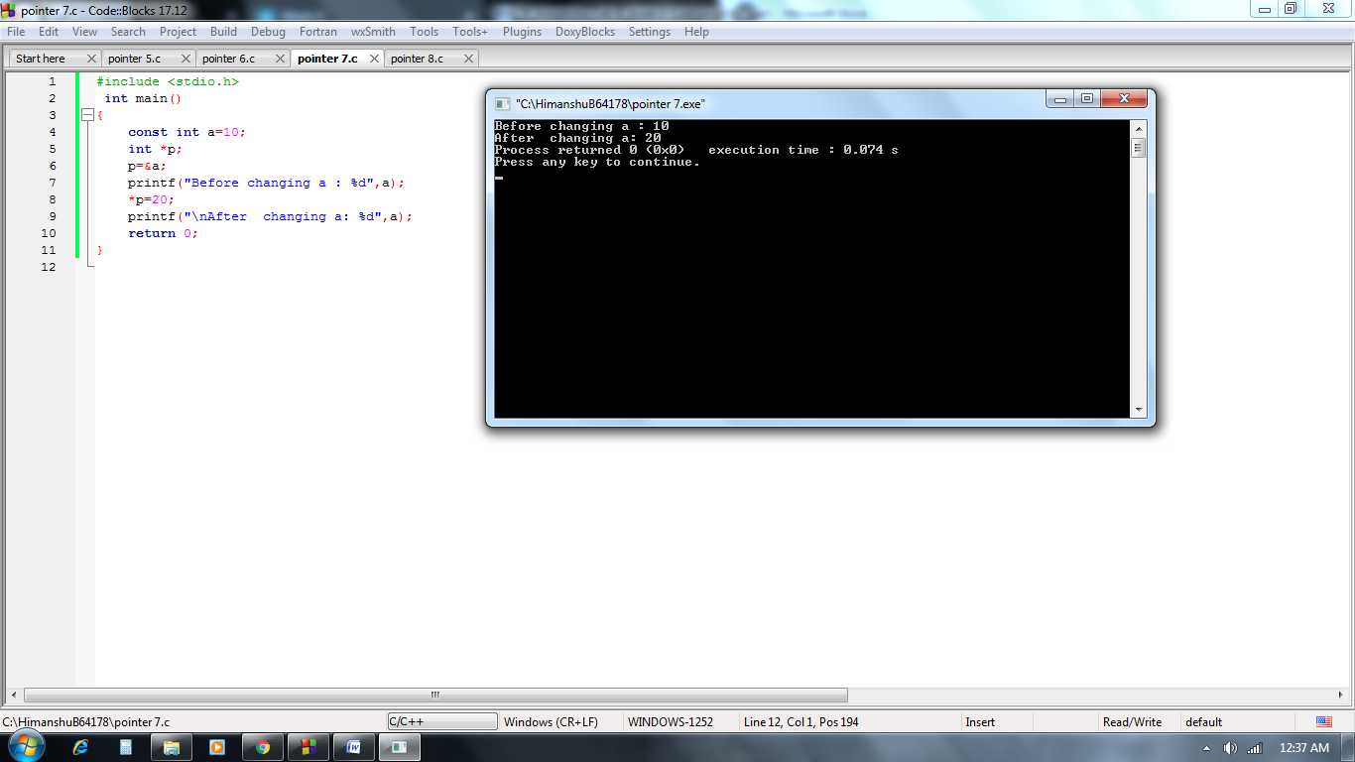

***Q8)****Write a C program to read and print student details using structure pointer, demonstrate example of structure with pointer.*

**Solution:**

#include <stdio.h>

struct student{

char name[30];

int roll;

float perc;

};

int main()

{

struct student std;

struct student *ptr;

ptr= &std;

printf("Enter details of student: ");

printf("\nName ?:");

gets(ptr->name); //gets((*ptr).name);

printf("Roll No ?:");

scanf("%d",&ptr->roll); //scanf("%d",&(*ptr).roll);

printf("Percentage ?:");

scanf("%f",&ptr->perc); //scanf("%f",&(*ptr).perc);

printf("\ndetails: ");

printf("\nName:%s \nRollNo: %d \nPercentage: %.02f\n",ptr->name,ptr->roll,ptr->perc);

return 0;

}

